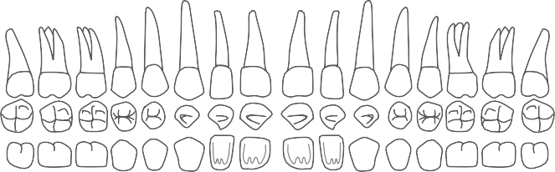
Annex 5. Adult Dental Chart*
VII. Annex 5

Body# .............................  Date ................................ | Post-mortem Dental Examination | Age range .....................................  Sex (circle): Male / Female / Unknown Ancestry ........................................

Please draw the shape of fillings/decay/crowns you can see on the maxillary teeth above. Please put a cross (x) through teeth that are missing.

Please provide any specific comments about the upper teeth including staining, wear, fixed crowns or bridges, and broken teeth, condition of the supporting bone, retained roots, and evidence of gum disease or anatomical variations.
Upper Denture > Present (Circle): | Y / N | Material (Circle): | Plastic or metal
Number of teeth on the denture: | ………….. | Or Full denture (Circle): | Y / N

...........................................................................................................................................................
...........................................................................................................................................................
...........................................................................................................................................................
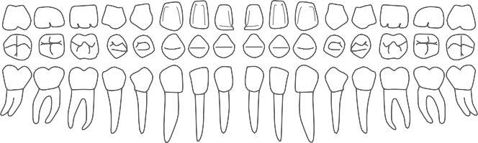
Occlusion (Circle): Overbite / Normal / Underbite

Please draw the shape of fillings/decay/crowns you can see on the maxillary teeth above. Please put a cross (x) through teeth that are missing.

Lower denture > Present (Circle): | Y / N | Material (Circle): | Plastic or metal
Number of teeth on the denture: | …………. | Or Full denture (Circle): | Y / N

* The contribution to this chart of Richard Bassed and Lyndal Smythe, Human Identification Service, Victorian Institute of Forensic Medicine, is gratefully acknowledged. Additional quadrants will be needed for deciduous dentition.

Please provide any specific comments about the lower teeth including staining, wear, fixed crowns or bridges, and broken teeth, condition of the supporting bone, retained roots, and evidence of gum disease or anatomical variations.
...........................................................................................................................................................
...........................................................................................................................................................
...........................................................................................................................................................

Describe the injuries to the hard tissues (if present):
...........................................................................................................................................................
...........................................................................................................................................................
...........................................................................................................................................................

Describe the injuries to the soft tissues (if present):
...........................................................................................................................................................
...........................................................................................................................................................
...........................................................................................................................................................

Name of Examiner / Doctor: ....................................................................

Signature of Examiner / Doctor: ....................................................................

